This Photo by Unknown Author is licensed under CC BY-NC-ND
This Photo by Unknown Author is licensed under CC BY-SA

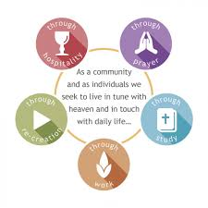
Developing your own Rule of Life

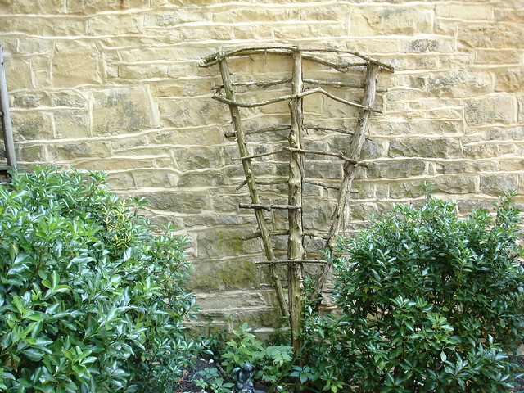
‘A Rule of Life might be likened to a

trellis: a framework giving shape

to our lives, enabling us

to grow stronger and more fruitful.’

Foreword from Bishop John
A Rule of Life
In recent years and months, many people from across the Diocese and beyond have been discovering the value of having a Rule of Life. More recently, in living through the Lockdown, people of any faith or none have been recognising the importance of having some kind of structure to the day, and for people of faith this will involve a rhythm of prayer.
The discipline of a Rule of Life, freely chosen, can help us in our relationship with God, with ourselves and with others and be an important anchor in our Christian life and discipleship. There are a few parishes in the Diocese where a Rule of Life has become an integral dimension of the corporate life of the people and a foundation for the ministry and mission of the church. In addition to this, there are many individuals who observe a Rule of Life, a number of whom are oblates or tertiaries of Christian monastic or missional communities.
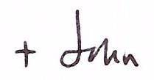
I am most grateful to the Revd. Craig Groocock, who has considerable experience in this area, for producing this paper on ‘Developing your own Rule of Life’. I commend it to you in confidence that those who take this up, will discover rich blessings in doing so.

What is a Rule of Life?
The idea of a Rule of Life developed in Christian monastic communities, and indeed, monasteries and convents today still function under a Rule, the best-known of which is that of St Benedict, dating from the 6th century. Monastic stability is based on accountability to the Rule of Life; it serves as a framework (or a trellis) for freedom – not as a set of rules that restrict or deny life, but as a way of living out our vocation alone and together. It is rooted in Scripture, pointing always to Christ; and, in the words of St Benedict, it is ‘simply a handbook to make the very radical demands of the gospel a practical reality in daily life.’

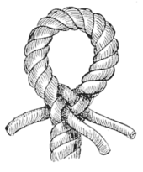
The strands of a rope
A rope is only as strong as the strands that are interwoven to make it so. So it is in our walk with God. The various aspects, or hooks, of our Rule are similarly like the strands of a rope, we need them together to give strength in our daily walk with God. When developing our own Rule of Life, it is worth considering what ‘hooks’ or strands we will build the Rule on.

What a Rule is not
As it says above, the purpose of a Rule of Life is to provide a framework in which you can swing, flourish and grow - not a straitjacket that restricts you and is unworkable. A Rule of Life is not something we create and use to beat ourselves up with when we don’t fulfil it. It is a tool to help us in our daily walk with God. Sure, the Rule should give us enough of a ‘pinch’ so that’s its worth having but it should not be unrealistic. Our Rule is individual to our needs and circumstances and is certainly not a ‘one size fits all’ method. However, it is good to have some ‘hooks’ on which to build our own Rule e.g. daily prayer, study, work etc.
Your Rule of Life and your soul friend. Having someone you can meet with regularly is good practice in our spiritual lives. It might sound like a grand term - spiritual director - but whatever term you use, it’s the person that matters. Try to identify someone you trust who will act as a critical friend. Someone who has the experience and maturity to walk alongside you and help you see the way ahead. Your ‘soul friend’ will be invaluable in helping you formulate your Rule of Life. They will also be useful in helping you reflect on the Rule as you work with it. Rules of Life are works in progress and any good Rule will need adapting and modifying as you go along. If you haven’t got a soul friend/spiritual director yet and would like to identify someone, then feel free to contact Lissy Clarke in the Diocese: spiritualdirectorcov@gmail.com. Lissy will be able to help you identify the right person for you.
How this might work for you The graphic on the left suggests five areas (hooks) on which we might develop our own Rule of Life: Please note: There are many different types of ‘hooks’. The following is simply one model illustrating five hooks that work well:
- Prayer – the daily offices, contemplative prayer, meditation, your ‘quiet time’ with God, corporate worship etc.
- Study – Bible reading, reading books, listening to podcasts, learning something new, the study of nature through daily walking and finding time to be outside.**
- Work – inner work (personal development) & outer work (doing something physical each day like gardening for example).
- Re-creation – rest, relaxation, hobbies, interests
- Hospitality – towards husband, wife, children, family, friends and neighbours.

** Poem by Wendell Berry
When despair for the world grows in me
and I wake in the night at the least sound
in fear of what my life and my children’s lives may be,
I go and lie down where the wood drake
rests in his beauty on the water, and the great heron feeds.
I come into the peace of wild things
who do not tax their lives with forethought
of grief. I come into the presence of still water.
And I feel above me the day-blind stars
waiting with their light. For a time
I rest in the grace of the world and am free.
(The Peace of Wild Things, Wendell Berry, Penguin, 1964)

A word about ‘Intentionality’
Whether you live in a monastery, are a member of a new monastic community or are trying to live a disciplined spiritual life on your own as a priest or lay person, the word ‘intentional’ is so key. Being intentional about our way of life means that this matters to us and that we take it seriously. If we want to get fit, we will need to be intentional in how we train, if we want to learn to play the violin, we will be intentional in how we practice. The same is true in our spiritual lives. If we want to grow closer to God, we will need to be intentional in our actions – having a personal Rule of Life can help us in this.

Some questions you might ask first of all
Receiving: How and when do I pray? How do I listen to God? What nourishes and energises me? What stops me from receiving God’s grace?
Walking: What difference does being a follower of Jesus make in your life and relationships? How might you take a step closer to the teaching and example of Jesus and the apostles?
Reflecting: What do my everyday life and words say to my family, work colleagues, friends and neighbours during the week? How does my life contribute to God’s kingdom of love and justice?
You may find it helpful to talk this through with a soul friend/director, minister or a trusted friend.
When you’ve decided on your responses you might like to record them on the suggested Rule of Life sheet below. As you do so, commit your intention to God and continue to ask for God’s help and grace.
As your Rule becomes part of your natural rhythm helping you to grow, it will be good from time to time to review and modify it accordingly. Your Soul Friend / Director / Mentor can help with this. See how it works out for you!

Agreeing your personal Rule of Life.
Okay, as you start remember to be intentional, specific and realistic. It might be advisable to write down the specifics in your Rule beginning with the words; ‘As I can ‘, for example, ‘As I can I will say morning and evening prayer each day of the week’. This recognizes that we can’t always do something we intend to; life gets in the way and our plans change. Our intention is what matters, ‘as I can . . .’ acknowledges this – be gentle on yourself! So, spend some time now reflecting on these areas:-
Daily Prayer – How and when will you do this? Daily offices? times of silence and meditation? Reading and studying the scriptures prayerfully?
Study – What will this consist of for you? How do you intend to read the scriptures? What about reading devotionally, theologically? Don’t forget reading simply for pleasure too! Do you intend to go on a course? Build in something about the ‘study of nature’ (taking time to simply be and enjoy all that God has given).
Work – Consider the ‘inner’ and ‘outer’ aspects of work for you. Do some gardening perhaps and offer that to God as you do so. Think more holistically in terms of your life and ministry. How will you work on the inner aspects of your life? What about having a Spiritual Director, the Anam Cara (soul friend) as the ancient Celtic church described them. How often will you meet with that person? Re-creation – Don’t neglect ‘sabbath’ time and rest. What hobbies and interests do you want to pursue? What exercise are you going to include? Important that you include things that revitalize and re-energize you.
Hospitality – Don’t neglect your family and friends, be intentional in making time for them, diary that time if need be. How will you show hospitality to others (hospitality of home and heart).

The following page gives an example of a Rule of Life and how it might look. Of course, no two rules of life will look the same. Your rule will be unique to you. Just remember, the Rule is to help you in your walk and growth with God.

An example of a Rule of Life
‘As I can . . . . . . . ‘
Prayer – I will say morning & evening prayer every day.
I will spend 20 mins each day in silent meditation.
Study – I will read the lectionary readings each day as part of my daily prayers.
I will go for a walk each afternoon and connect with God there.
I will seek some aspect of training each year to develop my ministry.
I will read a theological / devotional book each month.
Work – I will meet my Spiritual Director four times a year and go on an annual retreat.
I will do some gardening each day
I will keep a journal or diary to help in my personal development.
Recreation – I will exercise e.g. jog / cycle / go for a walk three times a week.
I will pick up that hobby again and spend some time each day enjoying it.
I will try to always eat well and look after myself.
Hospitality – I will always put my family first and make time with them my priority.
I will try to live with an attitude of open heart and mind.

Please feel free to use the sheet below to help you in devising your Rule of Life. Add further areas if you wish. The Rule is yours! You might want to sign and date it too and keep it safe somewhere. The Rule works as a wonderful tool for reflection as you look back over it again in maybe three or six months’ time.
My Rule of Life
Daily Prayer – ‘As I can I will . . .

Study – ‘As I can I will . . .

Work – ‘As I can I will . . .

Re-creation – ‘As I can I will . . .

Hospitality – ‘ As I can I will . . .

Signed ___________________________ Date _______________________ Review ________________________
For further advice on developing your Rule of Life then please contact Reverend Craig Groocock: Kankudai43@aol.co.uk

