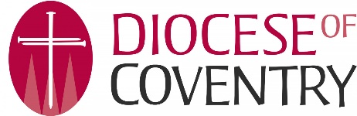[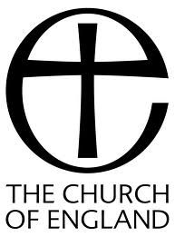](http://www.google.co.uk/imgres?rls=com.microsoft:en-gb:IE-Address&biw=1843&bih=946&tbm=isch&tbnid=KRWjP6jDy9DoOM:&imgrefurl=http://www.stthomasheptonstall.com/links.php&docid=6RJkGoAm45HvvM&imgurl=http://www.stthomasheptonstall.com/resources/CofE-logo-v3-BW.jpg&w=1339&h=1811&ei=7PGVUY-LC-eO0AXQlYEo&zoom=1&ved=1t:3588,r:50,s:0,i:315&iact=rc&dur=1076&page=2&tbnh=182&tbnw=139&start=29&ndsp=37&tx=98&ty=113)

**Equal Opportunities Form**

Coventry DBF wants to meet the aims and commitments set out in its equality policy. This includes not discriminating under the Equality Act 2010 and building an accurate picture of the make-up of the workforce in encouraging equality and diversity.

The organisation needs your help and co-operation to enable it to do this, but filling in this form is voluntary.

The information you provide will stay confidential and be stored securely and limited to only some staff in the organisation’s Human Resources function.

**What is your gender?**

|  |  |
| --- | --- |
| Man |  |
| Woman |  |
| Non-Binary |  |
| Other – Please specify |  |
| Prefer not to say |  |

**Are you married or in a Civil partnership?**

|  |  |
| --- | --- |
| Yes |  |
| No |  |
| Prefer not to say |  |

What is your age bracket?

|  |  |
| --- | --- |
| 16-24 |  |
| 25-29 |  |
| 30-34 |  |
| 35-39 |  |
| 40-44 |  |
| 45-49 |  |
| 50-54 |  |
| 55-59 |  |
| 60-64 |  |
| 65+ |  |
| Prefer not to say |  |

**What is your ethnicity?**

Ethnic origin is not about nationality, place of birth or citizenship. It is about the group to which you perceive you belong.

White

|  |  |
| --- | --- |
| English |  |
| Welsh |  |
| Scottish |  |
| Northern Irish |  |
| Irish |  |
| British |  |
| Gypsy or Irish Traveller |  |
| Other – Please specify |  |
| Prefer not to say |  |

Multiple/Mixed Ethnic Groups

|  |  |
| --- | --- |
| White and Black Caribbean |  |
| White and Black African |  |
| White and Asian |  |
| Other – Please specify |  |
| Prefer not to say |  |

Asian/ Asian British

|  |  |
| --- | --- |
| Indian |  |
| Pakistani |  |
| Bangladeshi |  |
| Chinese |  |
| Other – Please specify |  |
| Prefer not to say |  |

Black/ African/ Caribbean/ Black British

|  |  |
| --- | --- |
| African |  |
| Caribbean |  |
| Other – Please specify |  |
| Prefer not to say |  |

Other ethnic group

|  |  |
| --- | --- |
| Arab |  |
| Other – Please specify |  |
| Prefer not to say |  |

**Do you consider yourself to have a disability or health condition?**

|  |  |
| --- | --- |
| **No** |  |
| **Prefer not to say** |  |
| **Yes – please specify** |  |

**What is your religion?**

|  |  |
| --- | --- |
| **No religion or belief** |  |
| **Buddhist** |  |
| **Christian** |  |
| **Hindhu** |  |
| **Jewish** |  |
| **Muslim** |  |
| **Sikh** |  |
| **other – please specify** |  |
| **Prefer not to say** |  |