CARING FOR CREATION, OUR FRIDAY PRAYER THEME FOR APRIL – collated by Godfrey Armitage, Rev Charlotte Jackson & Rev Caroline Hammond
God’s intention for the earth is far removed from a wasteland. Very simply, earth’s purpose is not to be a chaos – translated also as a “waste,” but rather to “be inhabited,” to be a home for life. And God judges our behaviour based on how it contributes to this larger goal. Do our lives, our consumption habits, and the waste that we create, help Creation flourish? God loves people and creation with abandon. God affirms this love repeatedly, reminding us often that we were created caringly, with a good purpose. Can we start by turning our own homes, and our houses of worship, into communities that treat the after-effects of our consumption with the same loving abandon that God shows us - rather than thoughtlessly abandoning our waste in ways that hurt the earth?
supplied by Rev Charlotte Jackson, from The Collective resources
The theme this month is caring for creation as expressed in The Fifth Mark of Mission of the Anglican Communion. This is defined as ‘To strive to safeguard the integrity of creation, and sustain and renew the life of the earth’. Echoing Psalm 104:30 we pray “Send forth your Spirit, Lord, Renew the face of the earth”. This reminds us that it is God who renews the earth, and we are called to work alongside him, a task which Adam, in his bid for independence failed to do but which Jesus, the new Adam, saves us for and commissions us to do.
Godfrey Armitage, Diocesan Environment Officer, has chaired the Diocesan Environment Group since September 2015, after he had helped to organise the 2015 Conference ‘Reconciling a Wounded Planet’ at Coventry Cathedral; here we heard ‘stories of hope for a world in environmental crisis’. Godfrey also chairs the Net Zero Carbon 2030 Steering Group and is on DAC, hoping to steer parishes in environmentally-friendly directions as they come up with new projects in their buildings and churchyards. He is a tutor for the Christian Rural and Environmental Studies Certificate programme. He has shared his story of his Christian journey and his love of ecology and biodiversity in one of the 2021 Churches Count on Nature webinars (https://www.youtube.com/watch?v=a0b3e5yu7Oc). As Christians, we believe that God not only created everything, but is actively involved in his creation, so it is important to understand how ecosystems work, how ecological communities are structured, how species come and go and how humans impact the world. Scientific understanding helps us to be ‘planetwise’ * and to be effective stewards. (*title of a book by Revd Dave Bookless).

A PLACE OF TRANQUILITY AND MEDITATION. AN OPPORTUNITY TO STOP AND RELAX.
With plenty of labour, love and donations, we have created a space of retreat. Around the garden you can find, a barefoot walk, a fire pit area, an arbor for quiet reflection, a cross, a labyrinth and lots of other developments that are beginning to transform the space. Background The Garden of Hope — St John's Church (stjohnswestwood.co.uk) A simple cross (very much like one which was a feature of the gardens at Offa House – the former Diocesan Retreat Centre) forms one focal point, but there are many others. At just under an acre this is a very large space to conserve and develop; Caroline, curate, with a team of enthusiastic volunteers, has been keen to repurpose things like baths and tyres found on the land. It was in March 2020, just over three years ago that Caroline had felt that this fallow field could become a space for people to come to; ‘more of a garden that needed pursuing’. She had enjoyed retreats at Red Hill, Lee Abbey, Launde Abbey, a cottage in Italy, and Breathing Space in Coventry. Background breathing space coventry – finding beauty and stillness in the bustle of the city. She believes that the contemplative opens up the potential for ‘places of transformation in the liminal spaces’. Someone attending a Memory Café really connected with the ‘footprints’ space; an art retreat which used the church centre and garden (for inspiration) attracted over 30, with a waiting list. Caroline says there is ‘something about nature that draws us towards God’ – whether it be through being in nature, or doing in nature (gardening!). There has been a welcome level of interest and support from the local Residents Association, too. For prayer. Funding bids are in preparation for raised beds, a sit-on mower, tools and a shed for an allotment style kitchen garden, more seats and a temporary summer house structure. The scope for the Garden of Hope is enormous!
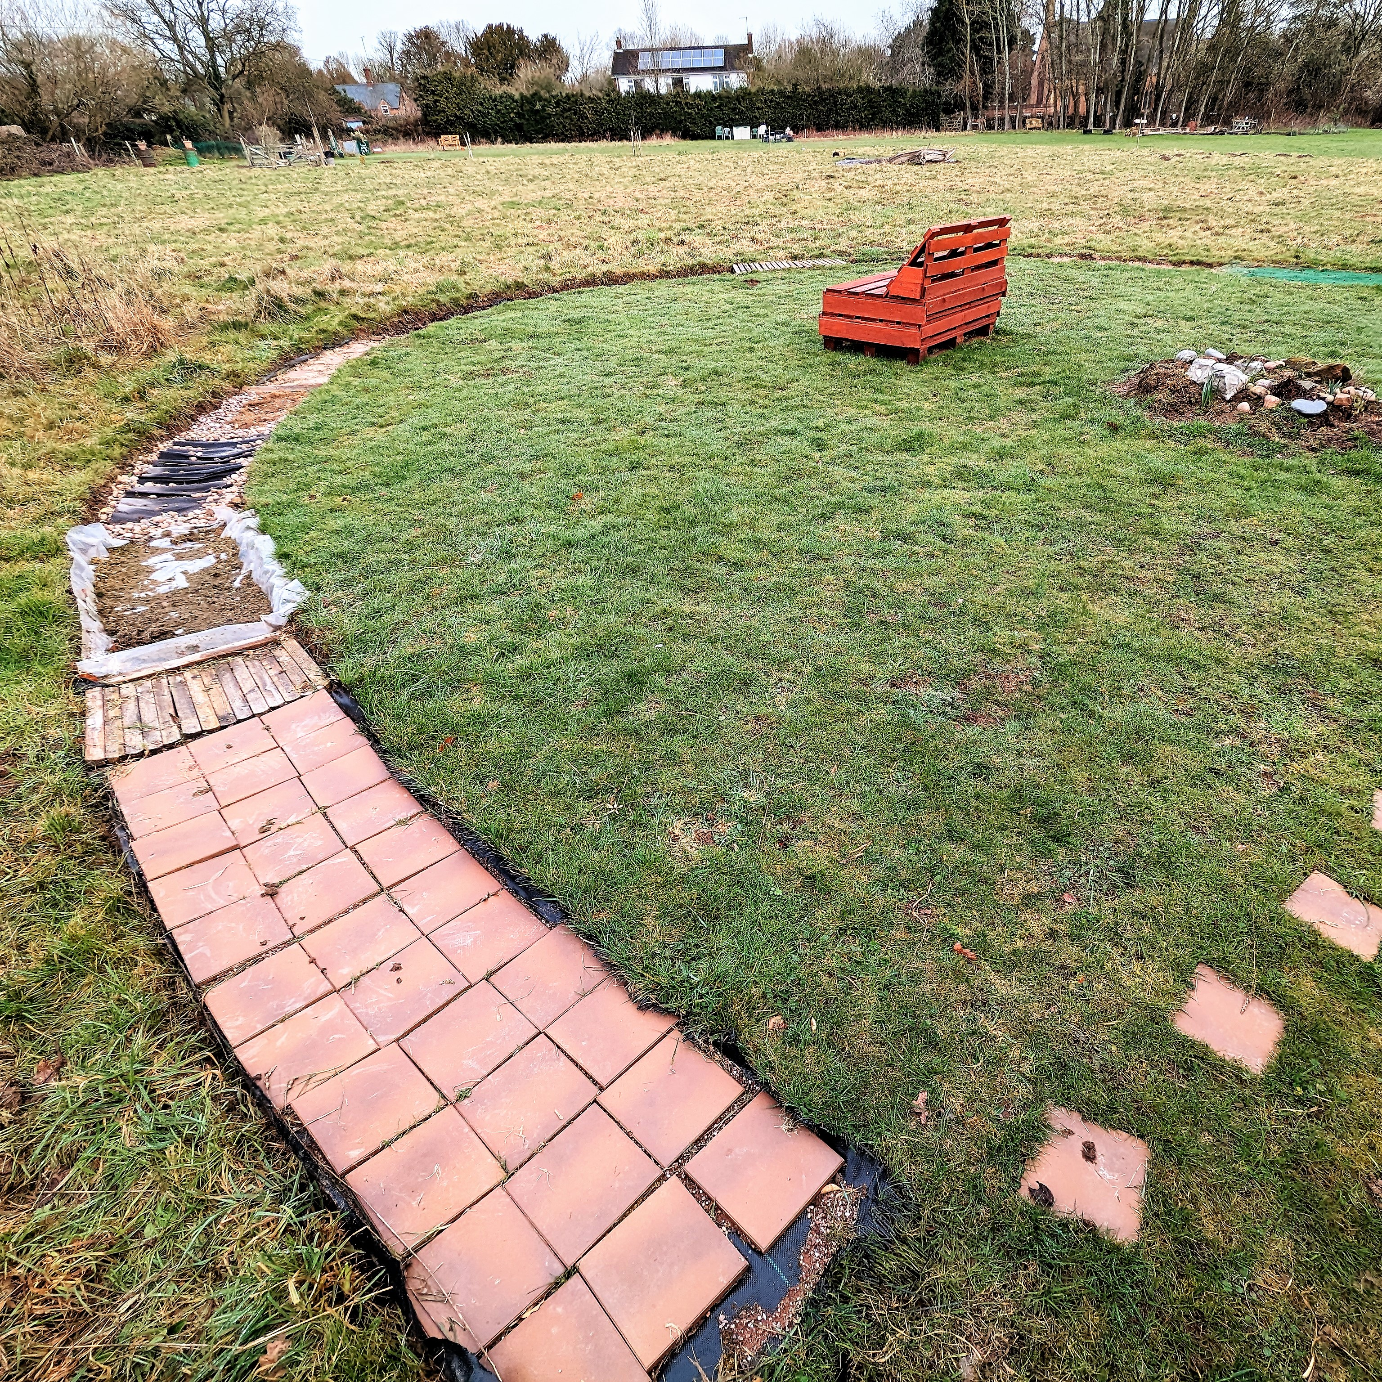
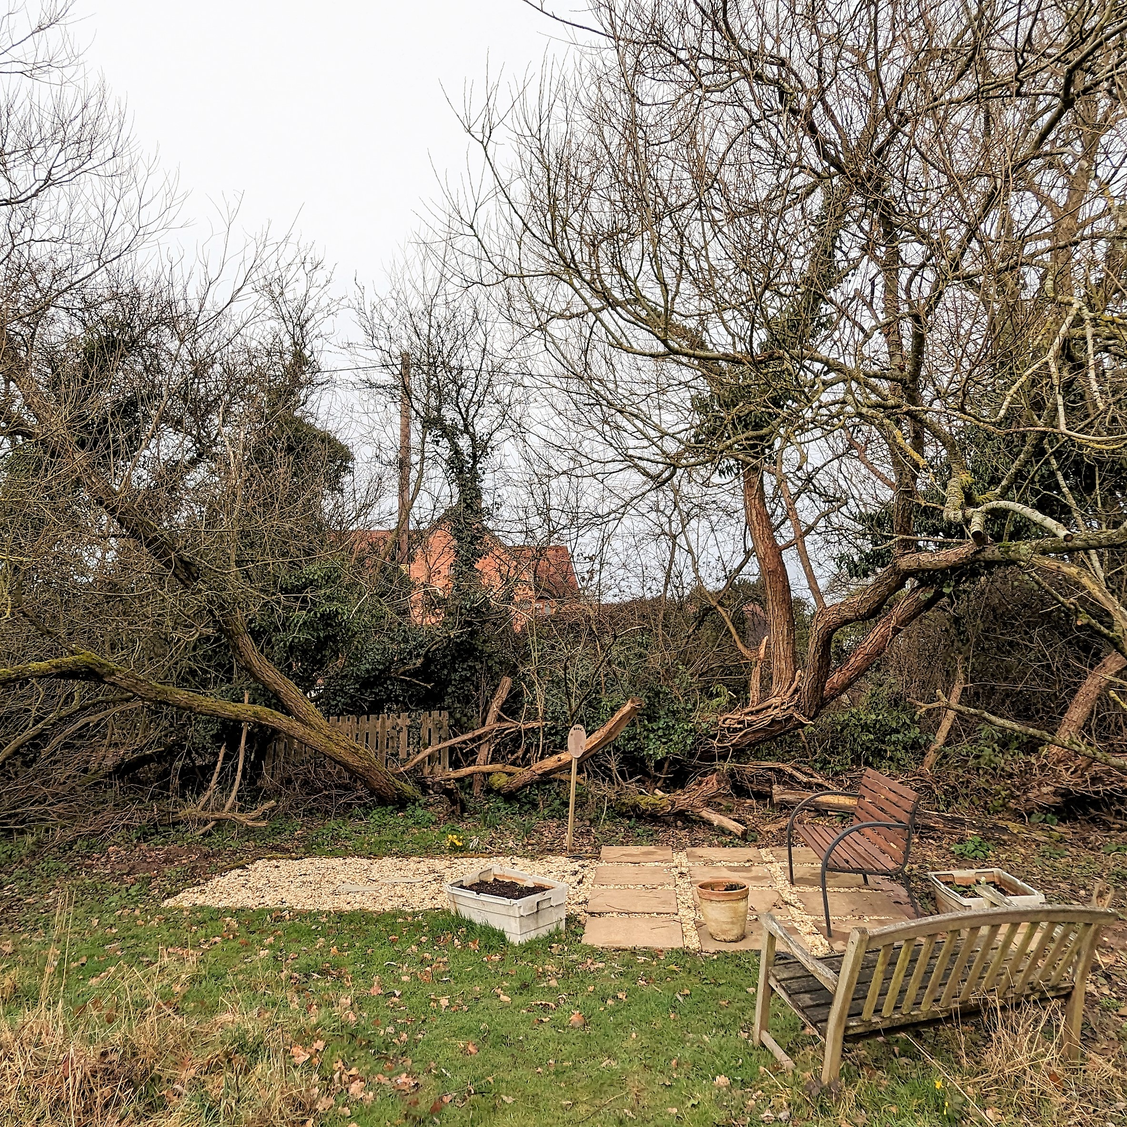
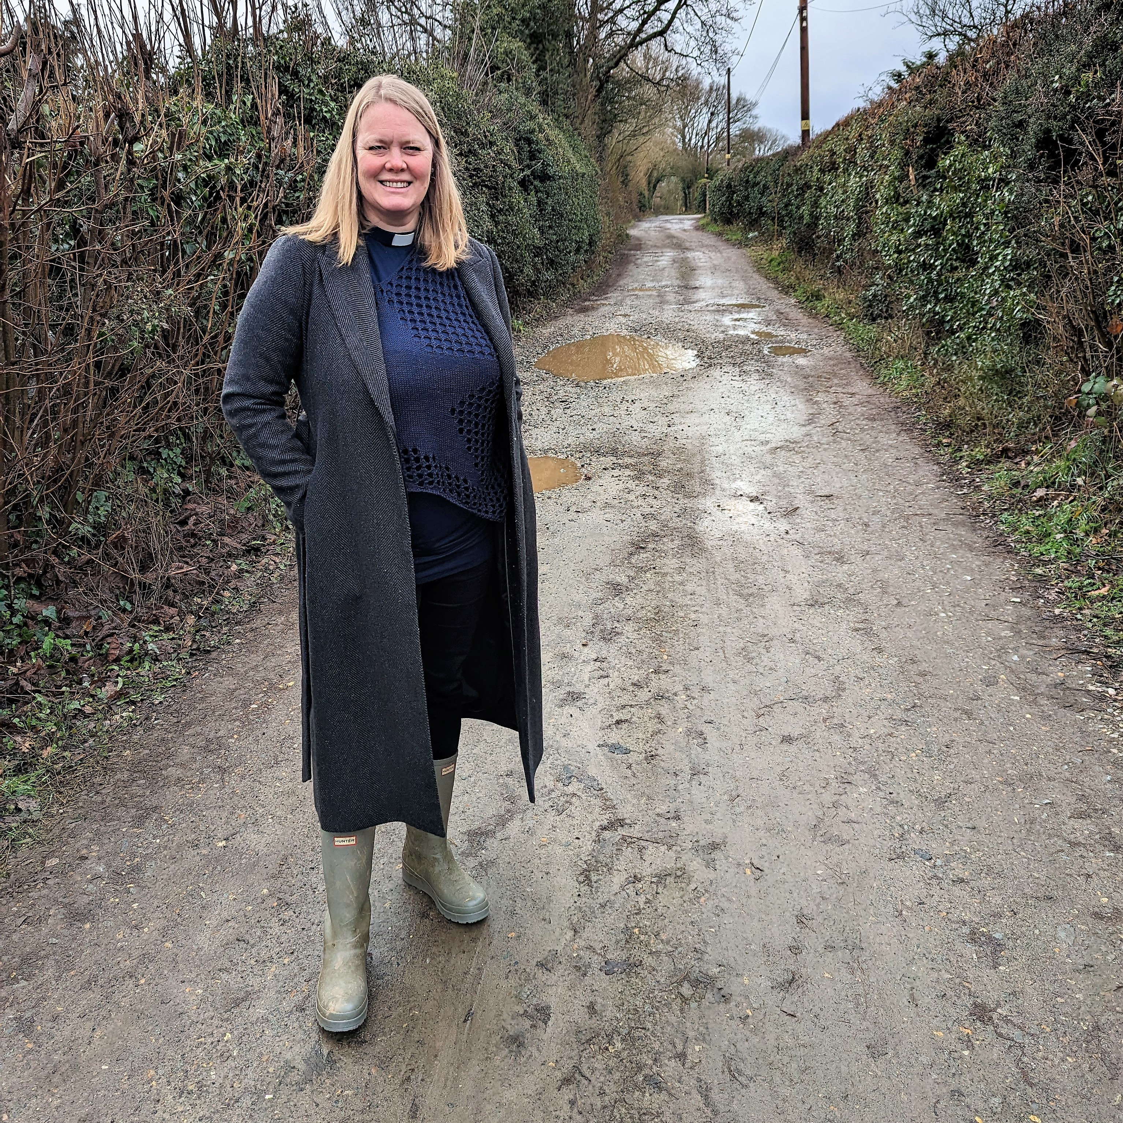
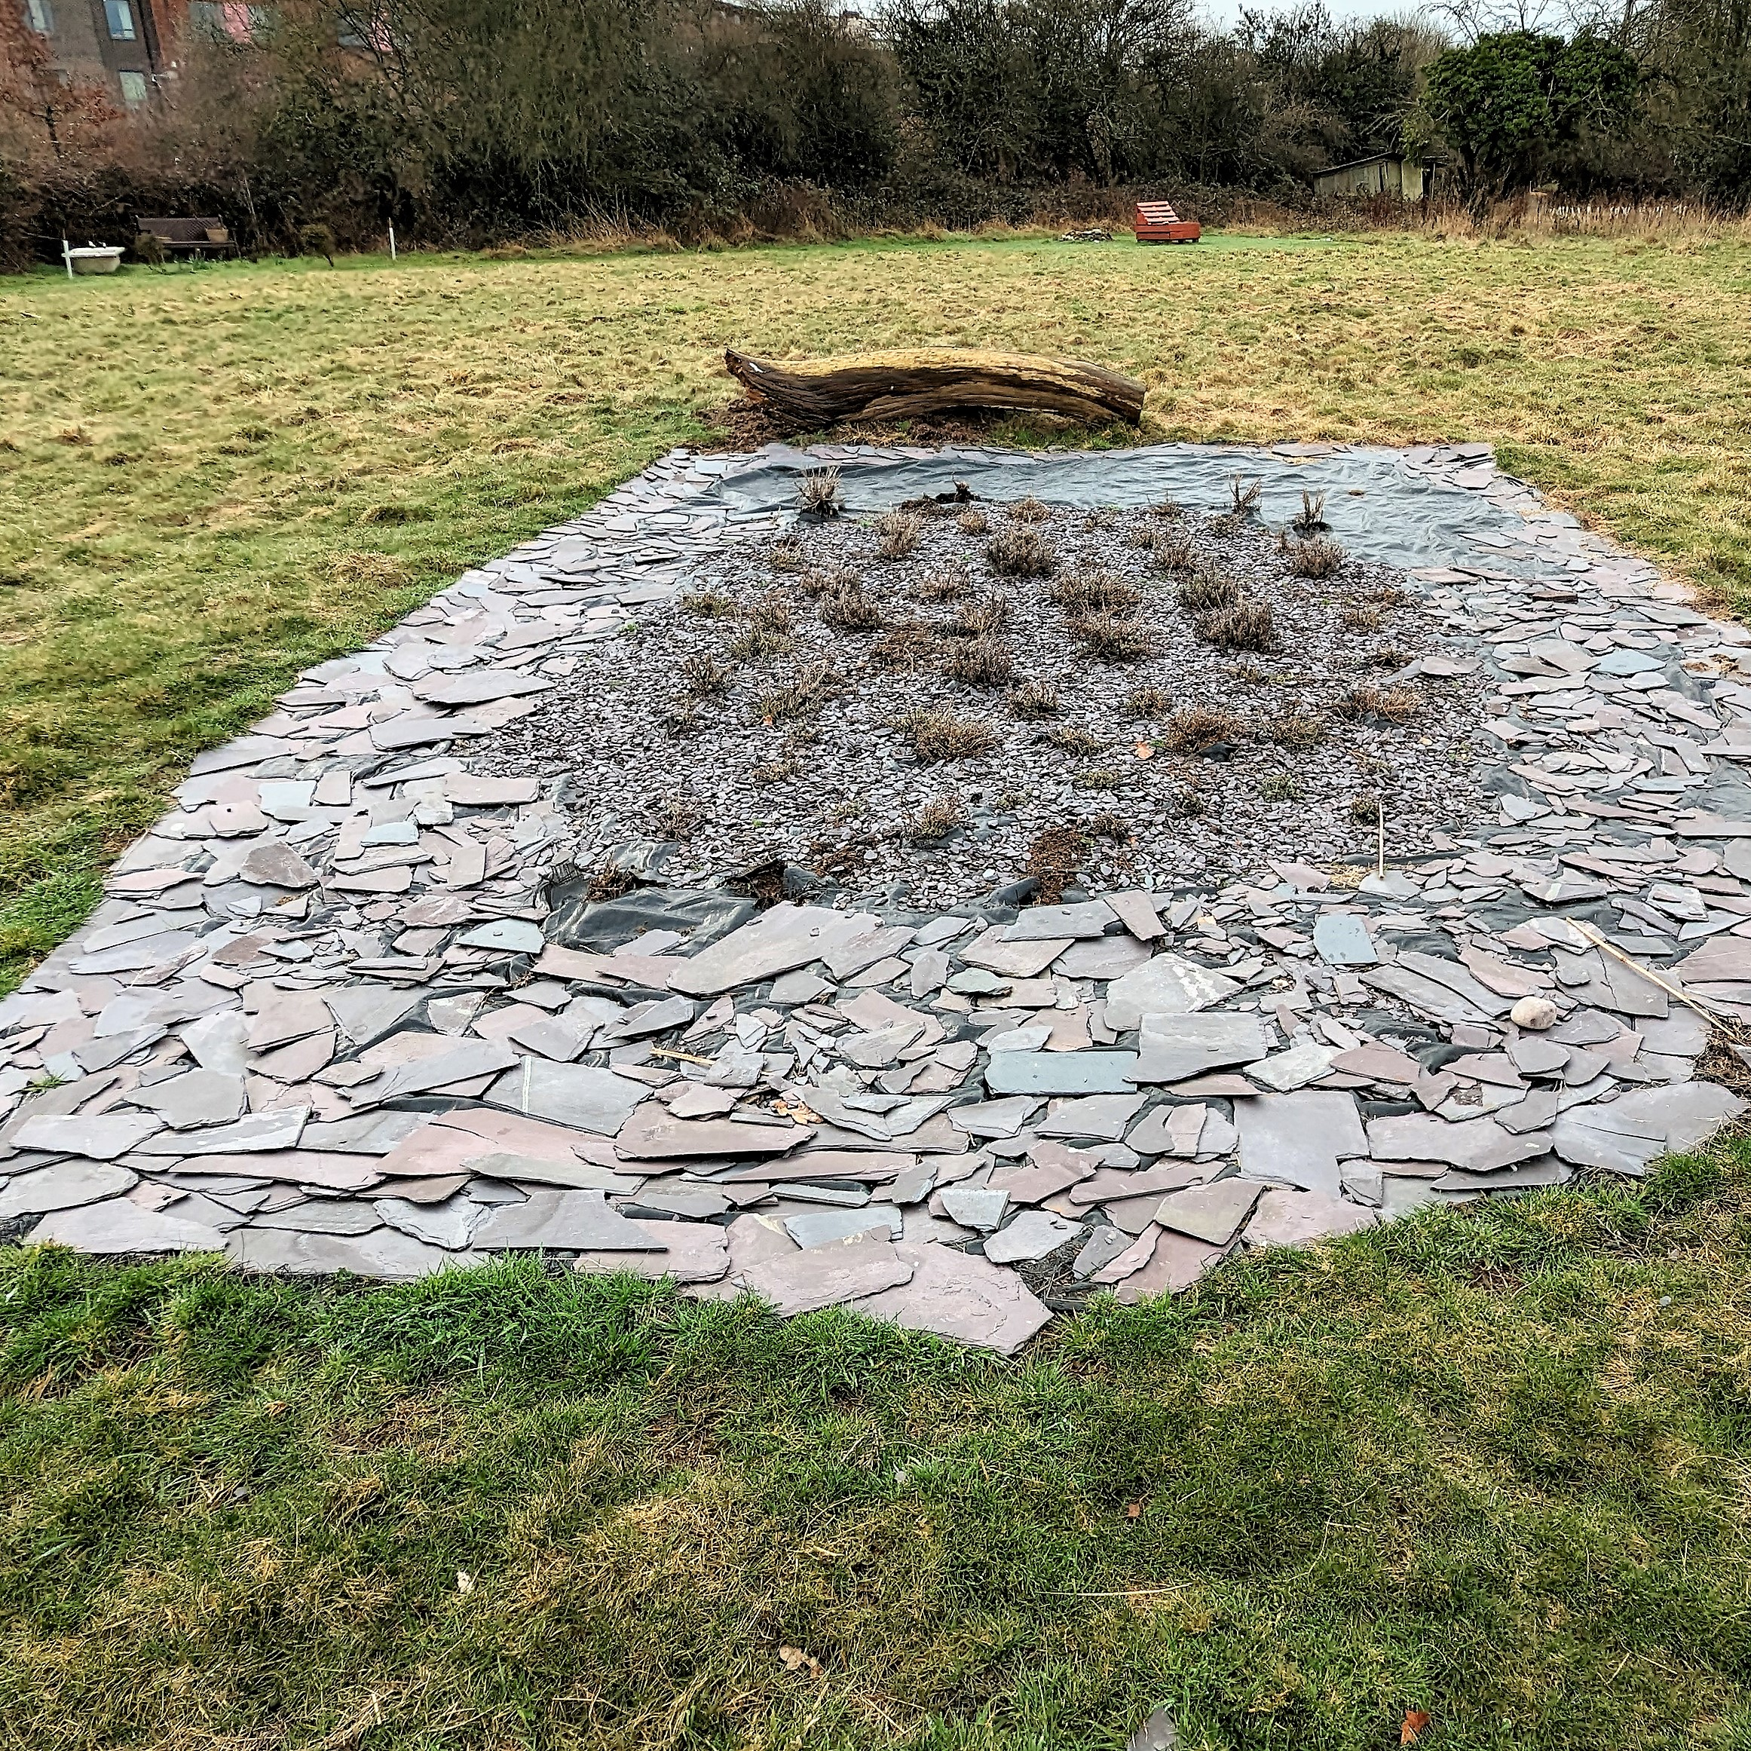
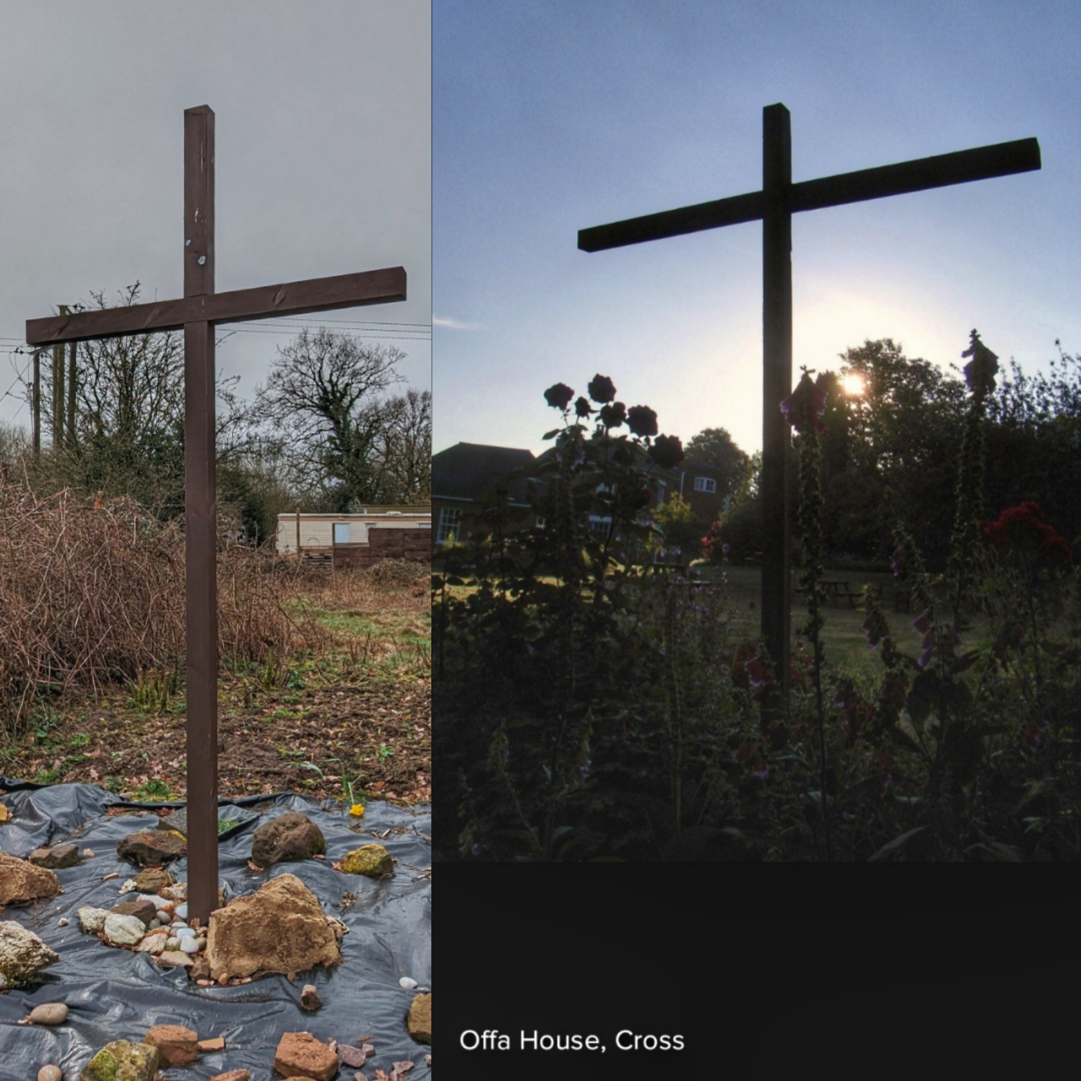
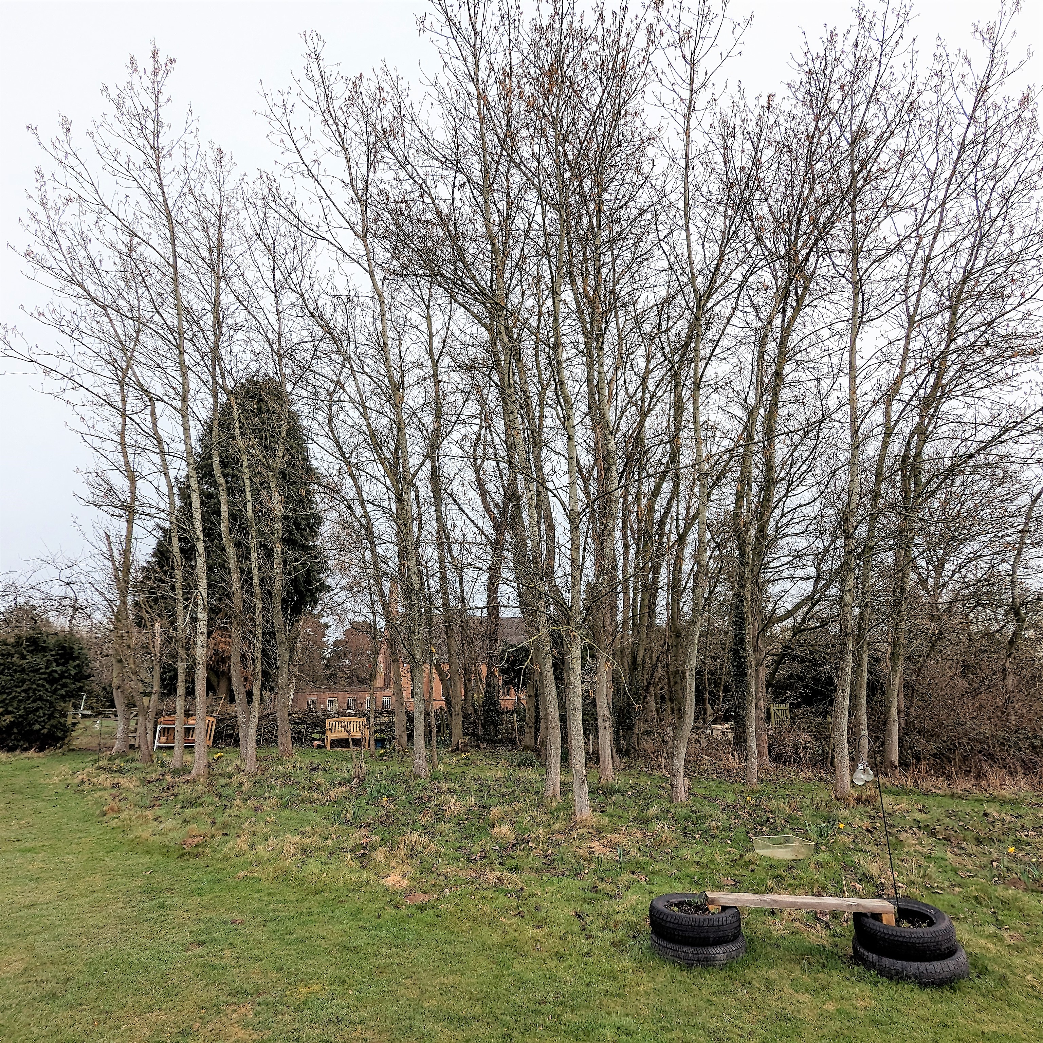

EASTER JOY April | 2023
Sunday | Monday | Tuesday | Wednesday | Thursday | Friday | Saturday
 |  |  |  |  |  | 1
 |  |  |  |  |  | Coventry South Deanery AD David Hammond
PALM SUNDAY 2 | 3 | 4 | 5 | MAUNDY THURSDAY 6 | GOOD FRIDAY 7 | HOLY SATURDAY 8
 | Allesley Park & Whoberley – C Andy March | St John’s Academy Primary School, Allesley Park | Expansion of Eco Churches in the Diocese | Eastern Green –  C Jo Joyce |  | St Andrews CofE Primary School, Eastern Green
EASTER DAY 9 | 10 | 11 | 12 | 13 | 14 | 15
Earlsdon –  C Tulo Raistrick | Bank Holiday Monday | Diocesan Audit & Risk Committee | Fletchamstead –  C Steve Burch | Garden of Hope at St John’s, Westwood | Caring for Creation | Bridge Benefice –  C David Hammond
2nd OF EASTER 16 | 17 | 18 | 19 | 20 | 21 | 22
Burton Green CofE Primary School | DOST; Safeguarding work in the Diocese | Tile Hill – C Ed Backhouse; Urban Plant | Leigh Academy Primary School, Tile Hill | Diocesan Environment Group; Bishop’s Core Staff | Caring for Creation | Earth Day Finham – C Matt Taylor;
3rd OF EASTER 23 | 24 | 25 | 26 | 27 | 28 | 29
Cathedral AGM | Styvechale –  C Josh Maynard | Cathedral Chapter; Diocesan Finance Group | DAC; Together for Change | Chapelfields –  C Edward Le Bran Powell | Caring for Creation | Fishers House, Cheylesmore
4th OF EASTER 30  Cheylesmore –  C Arthur Woo |  |  |  |  |  | AD = Area Dean  C = Clergy
PRAYER  DIARY | For Christ’s love compels us, because we are convinced that one died for all, and therefore all died. And he died for all, that those who live should no longer live for themselves but for him who died for them and was raised again.  2 Corinthians 5. 14,15 | Coming up – the Themes for the next 3 months are, Thy Kingdom Come (May), Growing Leaders (June) and Healthy Communities (July). Do consider sending me your prayer suggestions, and any other jottings. | BEING HEALTHY CHURCH  This month a Rewilding theme is being more widely introduced with various churches and participants across the Diocese. How can churches learn from rewilding projects in the UK how they might more naturally flourish? Natural Church Development, of course, advocates ‘all by itself growth’.  Mark 4.26-29
SPECIFIC DAYS IN APRIL 2023
1 – Coventry South Deanery Area Dean, David Hammond.
3 – St Christopher’s, Allesley Park & Whoberley R – Nic Thorpe We thank God for recent growth in numbers attending worship services. As we begin a new act of worship, “Quiet Waters”, where we explore God's presence through meditation, contemplation and mindfulness; that people would be blessed and renewed.
4 – St John’s Academy Primary School, Allesley Park H – Laura Stevenson
6 – St Andrew’s, Eastern Green – C Lynette Clark (PTO), R Lesley Lee (PTO), Sue Masters. Pray for all ordained and lay ministers in the Diocese and for those attending the Chrism Service at Coventry Cathedral. Give thanks for the gradual growth seen over the last year and the rebuilding of church following the pandemic. Prayer for growth in our families and children’s work and our mission and outreach.
8 – St Andrews CofE Primary School, Eastern Green H – Allison Underhill
9 – St Barbara’s, Earlsdon We thank God for the growing number of young families who have joined us in recent months, and for the joy they bring. Please pray that our homegroups will continue to grow and nurture faith, and for us all to grow deeper in our love for God, each other, our community and the world. The eco-committee and plans to develop a wild flower garden. C – Jeremy Bevan
Read Colossians 1: 15-20 about Christ, Creator, Sustainer and Reconciler of all; how does this relate to his creation as well as us?
12 – St James’s, Fletchamstead Thankful for the move of the Holy Spirit: for growth in numbers and encounters in power. Growth in children and youth work; Pray for continued growth through links with three schools - Leigh, Templars and Mount Nod. R – Anne Lancaster (PTO), Helen Kearney, Tim Pollard
14 – God our Father, You never cease the work you have begun and prosper with your blessing all human labour: make us wise and faithful stewards of your gifts that we may serve the common good, maintain the fabric of our world
and seek that justice where all may share the good things you pour upon us;
through Jesus Christ your Son our Lord, who is alive and reigns with you,
in the unity of the Holy Spirit, one God, now and for ever. AMEN
from Common Worship: Daily Prayer Rogation Days Collect 3
15 – Bridge Benefice – St John’s Westwood & St Stephen’s Canley For current roofing considerations to be environmentally friendly. C – Erin Gilmour, Caroline Hammond, Sarah Ashelby R – Andrew Smith
16 – Burton Green CofE Primary School H – Ash Atherton
18 – St Oswald’s, Tile Hill
19 – Leigh Academy Primary School, Tile Hill H – Lynn Lee; Church of England webinar on Solar Panels (4-5pm). Pray that churches may make appropriate choices to reduce their carbon footprint.
20 – Diocesan Environment Group; Bishop’s Core Staff. Church of England webinar on Preaching for God’s World, about including the environment when preaching.
21 – A Prayer for the Environment reflecting Coventry themes Father, Help us to tread your earth lightly, as people Reconciled by God with God, Reconciled by God with one another, and Reconciled by God to his wounded planet, Living simply that all may simply live, to the glory of our risen Saviour and Lord, Jesus Christ. AMEN Godfrey Armitage
22 – St Martin’s, Finham Giving thanks for the provision of an assistant chef in our busy Revive Coffee Shop; Praising God that finally we have switched on of our solar panel systems to power our church and connected buildings; Praying for our local secondary school and creative ways to engage with the students to support mental health and opportunities to share faith. C – Matt Ford R – Andrew Barclay
25 – St James’s, Styvechale R – Barbara Carr (PTO) We are thankful to God for new people joining our church in this season and people coming to faith.; Please pray for wisdom for our PCC and provision as we seek to build team.
26 – National Diocesan Environmental Officers Conference in Sheffield, also 27th.
27 – St Mary Magdalene, Chapelfields
28 – “I don’t think God is going to ask us how he created the earth, but he will ask us what we did with what he created.” Revd Richard Cizik, vice-president of governmental affairs for the National Association of Evangelicals in Goodstein, L. (2005) The New York Times 10 March 2005
29 –Fishers House, Cheylesmore Give thanks: We’ve almost completed the renovation of the Fishers house, and Carolyne Powell has joined us to help. We are recruiting for Fishers and need prayer as young adults is a wholly different mission field for Christ Church. C – Carolyne Powell
30 – Christ Church, Cheylesmore Give thanks: Our youth joined the Thrive weekend which was a significant time for building relationships and coming closer to Christ. Please pray: We are focusing on Prayer, including times of solitude and Lectio Divine. Pray that we experience God in new ways that enlivens our lives and mission. Scripture that inspires us: “Come and follow me, and I will make you fishers of people.” (Matthew 4:19) R – Tony Price
C = Clergy R = Reader H = Headteacher
Each month we focus on a different Deanery; this month it is Coventry South. In May we will be praying for Rugby Deanery, Kenilworth in June and in July, Alcester. I look forward to receiving updates from area deans and clergy, and anyone else with specific prayer requests.
Prayerful concern for the oceans, even if our Diocese is far from the sea …. Background High Seas Treaty Opportunity for the Church to Lead - Post - BioLogos
PRAYER JOTTINGS – APRIL 2023
- “To rule, in biblical thinking, means to be given a responsibility. The rule of humankind should be life-giving rather than exploitative …. Humanity has been given leadership over the rest of creation, as our very first responsibility. How well have we exercised it? Martin & Margot Hodson, Green Reflections: biblical inspiration for sustainable living. (BRF, 2021)’
- From Tyler Staton’s ‘Praying Like Monks, Living Like Fools – an invitation to the Wonder and Mystery of Prayer’ (Hodder & Stoughton, 2022) Chapter 5. On Earth as it is in Heaven. ‘God made Adam and Eve his managers here on the earth – God’s intercessors entrusted to call the shots. Psalm 115 puts it bluntly, “The highest heavens belong to the Lord, but the earth he has given to mankind….’ God did and does share the responsibility of managing the earth with people. Or to say it biblically, God made us to be his intercessors (p. 100). Simply and clearly ask that God’s kingdom will come where it is absent – friends outside of a relationship with Jesus, needs in our city and world, troubling or challenging circumstances, physical or mental illnesses. Ask for Jesus to come – anywhere and everywhere you know God’s kingdom of love and peace is lacking. Be brief, be specific (p. 114)
- Climate change action, for prayer. Coventry City Council are holding drop in sessions across the city during April, to review the Climate Change Strategy through to 2030. Background Climate Change Strategy | Let's Talk Coventry
- St Martin’s Finham have just finished the first phase of installing solar panels mounted outside their church hall on the Cornish Rocker system; this allows adjustment of the angle of panels according to seasons to maximise the solar energy captured.
- Churches Together in Earlsdon & Chapelfields (CTEC) alternate supporting a local or international charity and this year it is ‘Wildtracks Belize’. “This project supports the purchase of rainforest to create corridors for howler monkeys in Belize, as well as protecting coastal environments for manatees – as five churches we contribute in response to the mark of mission for Creation Care” Ian Leitch, Reader and chair of the eco-committee at St Barbara’s Church, Earlsdon, reports. Background About Wildtracks — Wildtracks (wildtracksusa.org)
- A Rocha UK supports the Eco Church movement in the UK. This is a learning community of churches of all shapes and sizes. It provides a framework to support any church and its leadership to take practical action on caring for God’s earth. It includes a toolkit of resources, an online award survey, a quarterly email update, online events, prayer forums and occasional conferences. Background Home - A Rocha UK Godfrey Armitage believes that the best practical way that we in our churches can care for creation is to register our church for the Eco Church programme (https://ecochurch.arocha.org.uk/). Since the programme started in 2016, almost 35% of our churches in the Diocese of Coventry have signed up. 41 of the 83 have obtained Bronze Awards, 11 have Silver and one has Gold. He is happy to accept invitations to speak about creation care and Eco Church at churches or at Deanery Synods.
- Reflections on Food https://atyourservice.arocha.org/en/just-food-2011-resource-pack/

- The River Sherbourne Background The Sherbourne Valley Project | Warwickshire Wildlife Trust
“Rivers feature prominently in Scripture. Psalm 46 reminds us “there is a river whose streams make glad the City of God where the Most High dwells” (v. 4). The Psalmists and Prophets regularly return to the theme of water flowing through the land, emphasising it is the Lord who creates streams and rivers (Habakkuk 3.9); they are an expression of praise (Ps 98.8) and their return to the land is a sure sign of His blessing (Ps 107.35), most especially after a time of spiritual drought. With this promise in view, the opening up of the River Sherbourne can become a symbolic act for the city of Coventry. It can remind our citizens that He has been present among us, with the prospect of a new thing being done and He has heard those who have cried out in distress. There is joy at a symbolic level, but it may also bring practical blessings, by providing access to these flowing waters for children in supervised and properly designed spaces. One can holiday almost anywhere in the country and see children playing safely in and around natural flowing water, but not yet in Coventry.”
Adapted from Revd Greg Smith, St Andrew’s Eastern Green, September 2018
DPD Contact: Clive.Hicks@Coventry.Anglican.org

