7. MDR Preparation Questions for Chaplains – Philip
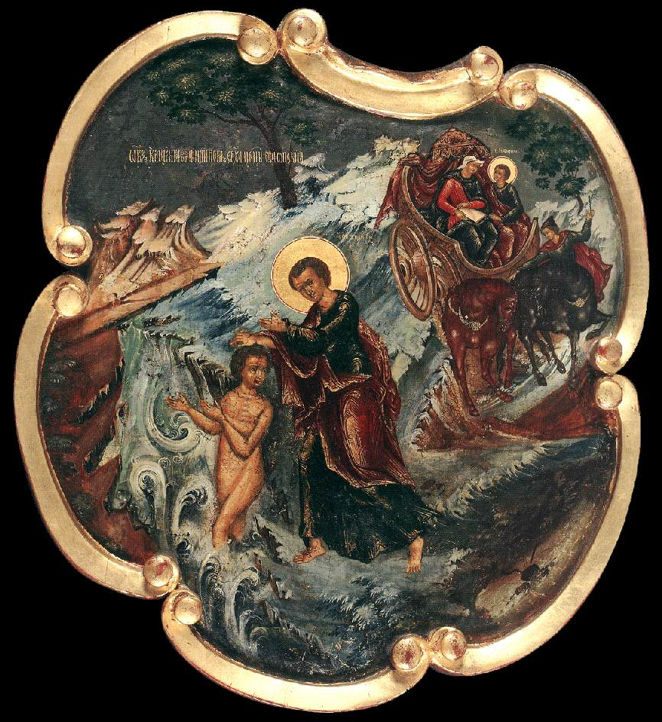
Chaplains offer a remarkable ministry as people of faith within institutions and organisations. The same model of MDR may not suit the shape of everyone’s ministry so we are pleased to offer a specific MDR template for chaplains. Chaplains have a choice whether to use this model, or one of the others: the hope is that you will choose the one which will best help you to reflect on your ministry.

This template is intended as a starting point for your reflections and for your discussion with your MDR reviewer, and if there are other matters that you wish to raise as part of your review, please indicate this at the end. This form will remain confidential between you and your MDR reviewer.

Questions for Reflection and Discussion
Please continue on additional pages as necessary.

As you prepare for your MDR, you are invited to read Acts 8:26–40.

In this passage, we read of Philip’s encounter with the Ethiopian court official as he travels from Jerusalem to Gaza. Prompted by the Spirit, Philip walks alongside the official’s chariot, talks with him, and is invited to sit beside him. During their conversation, Philip reveals the good news of Jesus and the official asks to be baptised. Immediately afterwards, the Spirit takes Philip elsewhere.

Whilst no story will reflect all the facets of someone’s ministry, there may be certain elements of the encounter between Philip and the official which resonate with the life and ministry of a chaplain. Like Philip, as a chaplain you may find yourself accompanying people for a while on their journey. Along the way you may at times be invited to share your faith, and have occasional encounters which are life-changing. Depending on your context, your ministry to some may only be fleeting, and this side of eternity you may not discover what happens next on their journey, nor how God has used you in their story of salvation. We never find out what became of the Ethiopian court official beyond the brief mention that “he went on his way rejoicing” and we are compelled to leave him in God’s hands.

As you read the passage, you may like to reflect on the nature of your own ministry, with its joys and its costliness.

- What has gone well in the past year? What do you want to celebrate?

- What has been challenging, frustrating or draining?

- How are you?

- What is your vision for your ministry?
To answer this question, you may want to draw on documents relevant to your post(s) eg. a Role or Job Description if you have one / vision statement etc.

- How far do you think you have been able to fulfil that vision over the past year?

- If you are also licensed in a parish or other context, or hold PTO, how far are you able to give time to this? Are there fruitful points of crossover between your ministry as a chaplain and these other forms of ministry?

- Is there anything you need to let go of over the coming year?

- How would you characterise your relationships at present

- within your ministerial context(s)?

- with friends and family?

- What would you or others identify as your current areas of weaknesses?
In addition to drawing on your own self-understanding, you are invited to reflect on the answers given to question 2 on the MDR Feedback Form for Nominated People.

- Given your context and responsibilities, what personal development would be helpful, or what skills or knowledge do you need to acquire?

Please turn over
- Recognising that peaks and troughs are part of every Christian journey, how would you characterise your spiritual life at present?

- As things stand at the moment, where do you see yourself

- in 3 years’ time?

- in 5–7 years’ time?

If there are other matters you wish to raise at your MDR, please indicate this here:

