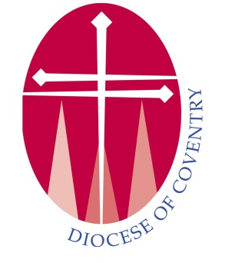 | Consent to Check the Status of a DBS Certificate With the DBS Update Service
Name of Church:
Name of Applicant:
Date of Birth:
Certificate issue number:
Date of issue:
Role in church applied for:
Organisation the DBS was checked by
Please take your DBS and show to the person requesting the check.

I give permission for the Diocese of Coventry to check the status of the above DBS certificate with the DBS Update Service. I understand that I will be notified by the DBS when this check has been made.

Signature of applicant: Dated:
Please return your completed form to your parish safeguarding officer or send direct to the diocesan office

Parish Safeguarding Officer or verifier
I confirm I have seen the DBS reference number above and confirm the workforce is for (delete as necessary)
- Adult workforce
- Child workforce
- Adult and child workforce
I can confirm that the above persons DBS has been checked for : (delete as necessary)
- Regulated children’s activities
- Regulated vulnerable adults activities’
- No regulated activity
Signature of PSO: Date

