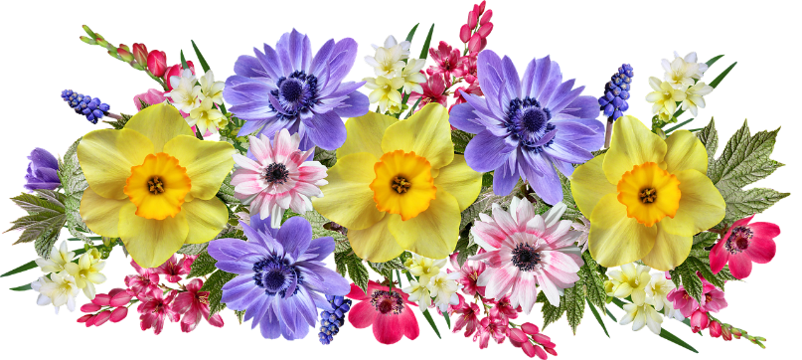
FLOWER FESTIVAL
To mark the Queen’s Jubilee
All Saints’ Church, Burton Dassett
Thursday, 2nd June - Sunday 5th June

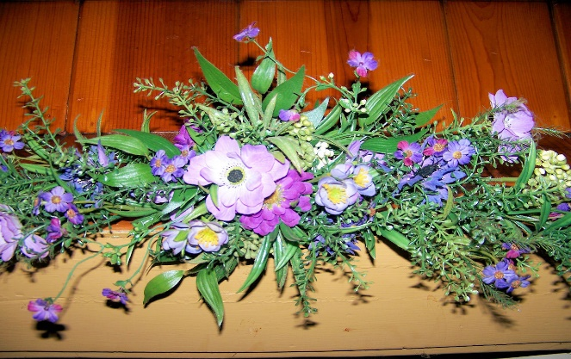

Afternoon Teas, Musical performances
Including the Military Wives Choir
Teas served 11am – 5pm
Entrance Free
For details on how to take part please contact:
Norma King: 01295 770292
Lynn Pearson: 01295 770580

