6. MDR for Associate and Assistant Ministers* – Mary and Paul
* eg. licensed clergy who spend an significant proportion of their time in secular employment /
extra-parochial ministerial contexts / fulfilling family commitments etc.

The church is gloriously enriched by the wonderful variety of shapes and forms that ordained ministry can take. For some, their ministry will mostly be exercised in one particular context eg. a parish or chaplaincy. For others, their ministry will mostly be exercised within secular employment or fulfilling family commitments. For still others, their working or family life is discrete from their ministry which may be exercised within an associate role.
The same model of MDR may not suit the shape of everyone’s ministry so we are pleased to offer a specific MDR template in order to try best to support those whose life and ministry weaves together these different strands. Those to whom this applies have a choice whether to use this model, or one of the others: the hope is that you will choose the one which will best help you to reflect on your ministry.
This template is intended as a starting point for your reflections and for your discussion with your MDR reviewer, and if there are other matters that you wish to raise as part of your review, please indicate this at the end. This form will remain confidential between you and your MDR reviewer.

Questions for Reflection and Discussion
Please continue on additional pages as necessary.

As you prepare for your MDR, you are invited to read the following passages of Scripture:
- Luke 1:26–38
- Acts 18:1–4
In the passage from Luke, we read of the angel Gabriel’s visit to Mary, and Mary’s extraordinary words of trust “Here am I, the servant of the Lord; let it be with me according to your word.” From then on, Mary’s life would be changed utterly by her pregnancy and the birth, life, and death of her son Jesus.
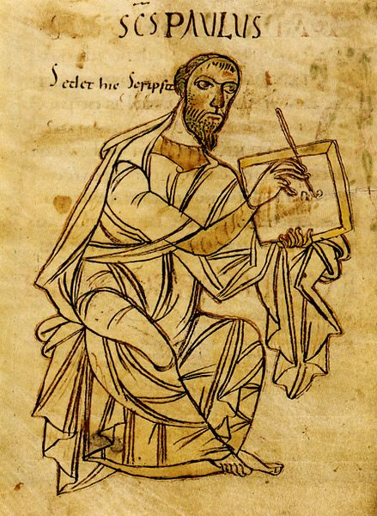
In the passage from Acts, we read of Paul working as a tentmaker in Corinth alongside Aquila and Priscilla, and preaching in the synagogue on the Sabbath.
Mary offers a model of vocation which is fulfilled through her love of and care for Jesus; Paul offers a model of ministry in which paid employment, and preaching and evangelism, are each allocated time. For them both, their response to God brings them joy and wonder, but is also deeply costly.
As you read the passages, you may like to reflect on the pattern of your own ministry, with its joys and costliness.

- What has gone well in the past year? What do you want to celebrate?

- What has been challenging, frustrating or draining?

- What is your vision for your ministry?
To answer this question, you may want to draw on documents relevant to your post(s) eg. a Role Description if you have one / parish vision statement / feedback from a recent 8EQs survey etc.

- How far do you think you have been able to fulfil that vision over the past year?

- Reflecting on the balance of your life, how far are you able to give time to your other commitments?

- Are there fruitful points of crossover between the different strands of your life and ministry?

- Is there anything you need to let go of over the coming year?

- What would you or others identify as your current areas of weaknesses?
In addition to drawing on your own self-understanding, you are invited to reflect on the answers given to question 2 on the MDR Feedback Form for Nominated People.

- Given your context and responsibilities, what personal development would be helpful, or what skills or knowledge do you need to acquire?

- How would you characterise your relationships at present

- with the incumbent / line manager / pastoral lead to whom you relate?

- with others within your ministerial context(s)?

- with friends and family?

- Recognising that peaks and troughs are part of every Christian journey, how would you characterise your spiritual life at present?

- As things stand at the moment, where do you see yourself

- in 3 years’ time?

- in 5–7 years’ time?

If there are other matters you wish to raise at your MDR, please indicate this here:

